# **Name: Abdurrahman Qureshi**

# **Roll No: 210451**

Practical No: 16

**1) Write a Program to display the time picker in spinner mode.**

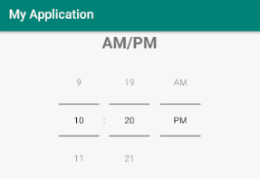

**XML CODE:**

<?xml version="1.0" encoding="utf-8"?>  
<LinearLayout xmlns:android="http://schemas.android.com/apk/res/android"  
 xmlns:app="http://schemas.android.com/apk/res-auto"  
 xmlns:tools="http://schemas.android.com/tools"  
 android:layout_width="match_parent"  
 android:layout_height="match_parent"  
 android:orientation="vertical"  
 tools:context=".MainActivity">  
  
 <TextView  
 android:layout_width="wrap_content"  
 android:layout_height="wrap_content"  
 android:text="AM/PM"  
 android:textSize="40sp"  
 android:layout_gravity="center"/>  
  
 <TimePicker  
 android:id="@+id/time_picker"  
 android:layout_marginTop="50dp"  
 android:layout_width="wrap_content"  
 android:layout_height="wrap_content"  
 android:timePickerMode="spinner"  
 android:layout_gravity="center"/>  
  
</LinearLayout>

**JAVA CODE:**

(NOT REQUIRED)

**OUTPUT:**

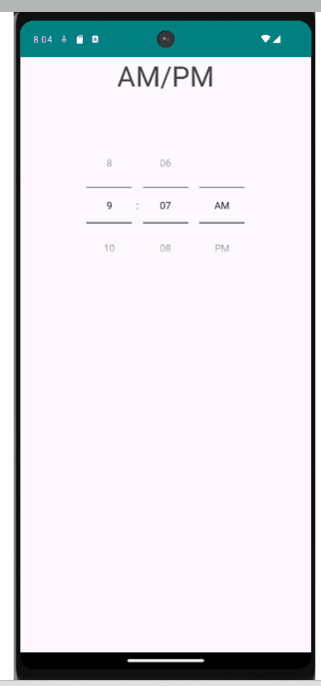

**2) Write a Program to display the time picker in 24 Hours format in spinner mode**

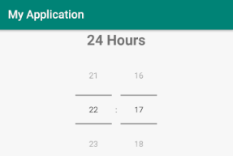

**XML CODE:**

<?xml version="1.0" encoding="utf-8"?>  
<LinearLayout xmlns:android="http://schemas.android.com/apk/res/android"  
 xmlns:app="http://schemas.android.com/apk/res-auto"  
 xmlns:tools="http://schemas.android.com/tools"  
 android:layout_width="match_parent"  
 android:layout_height="match_parent"  
 android:orientation="vertical"  
 android:padding="10dp"  
 tools:context=".MainActivity">  
  
 <TextView  
 android:layout_width="wrap_content"  
 android:layout_height="wrap_content"  
 android:text="24 Hour Format"  
 android:textSize="40sp"  
 android:layout_gravity="center"/>  
  
 <TimePicker  
 android:id="@+id/time_picker"  
 android:layout_marginTop="50dp"  
 android:layout_width="wrap_content"  
 android:layout_height="wrap_content"  
 android:timePickerMode="spinner"  
 android:layout_gravity="center"/>  
  
</LinearLayout>

**JAVA CODE:**

package com.example.madprac16;  
  
import androidx.appcompat.app.AppCompatActivity;  
import android.os.Bundle;  
import android.widget.TimePicker;  
  
public class MainActivity extends AppCompatActivity {  
  
 @Override  
 protected void onCreate(Bundle savedInstanceState) {  
 super.onCreate(savedInstanceState);  
 setContentView(R.layout.*activity_main*);  
  
 TimePicker timePicker = (TimePicker) findViewById(R.id.*time_picker*);  
 timePicker.setIs24HourView(true);  
 }  
}

**OUTPUT:**

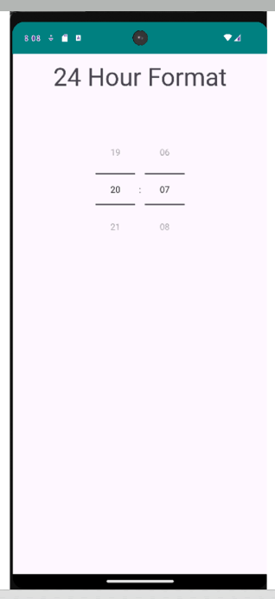

**3) Write a Program to display following output. Select and display date and time on click of “select date”, “select time” buttons respectively.**

**After clicking Select Date button After selecting date**

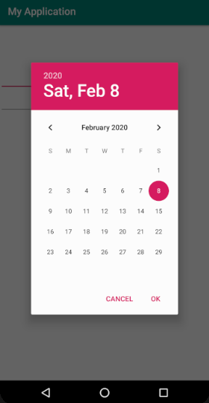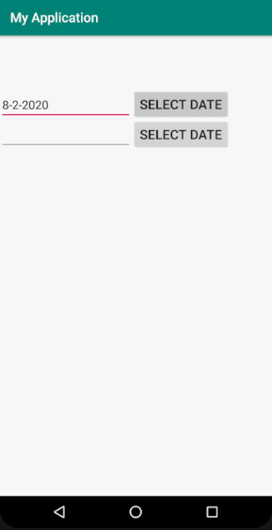

**XML CODE:**

<?xml version="1.0" encoding="utf-8"?>  
<LinearLayout xmlns:android="http://schemas.android.com/apk/res/android"  
 xmlns:app="http://schemas.android.com/apk/res-auto"  
 xmlns:tools="http://schemas.android.com/tools"  
 android:layout_width="match_parent"  
 android:layout_height="match_parent"  
 android:orientation="vertical"  
 android:padding="10dp"  
 tools:context=".MainActivity">  
  
 <LinearLayout  
 android:layout_width="match_parent"  
 android:layout_height="wrap_content"  
 android:layout_marginTop="40dp"  
 android:weightSum="5">  
  
 <EditText  
 android:id="@+id/edit1"  
 android:layout_width="wrap_content"  
 android:layout_height="wrap_content"  
 android:layout_weight="4"/>  
  
 <Button  
 android:id="@+id/button1"  
 android:layout_width="wrap_content"  
 android:layout_height="wrap_content"  
 android:layout_weight="1"  
 android:text="Select Date"/>  
  
 </LinearLayout>  
  
 <LinearLayout  
 android:layout_width="match_parent"  
 android:layout_height="wrap_content"  
 android:layout_marginTop="10dp"  
 android:weightSum="5">  
  
 <EditText  
 android:id="@+id/edit2"  
 android:layout_width="wrap_content"  
 android:layout_height="wrap_content"  
 android:layout_weight="4"/>  
  
 <Button  
 android:id="@+id/button2"  
 android:layout_width="wrap_content"  
 android:layout_height="wrap_content"  
 android:layout_weight="1"  
 android:text="Select Time"/>  
  
 </LinearLayout>  
  
</LinearLayout>

**JAVA CODE:**

package com.example.madprac16;   
import androidx.appcompat.app.AppCompatActivity;   
import android.app.DatePickerDialog;  
import android.app.TimePickerDialog;  
import android.os.Bundle;  
import android.view.View;  
import android.widget.Button;  
import android.widget.DatePicker;  
import android.widget.EditText;  
import android.widget.TimePicker;   
import java.util.Calendar;   
public class MainActivity extends AppCompatActivity implements View.OnClickListener {  
 Button datePickButton, timePickButton;  
 EditText dateText, timeText;  
 int year, month, day, hour, minute;   
 @Override  
 protected void onCreate(Bundle savedInstanceState) {  
 super.onCreate(savedInstanceState);  
 setContentView(R.layout.*activity_main*);  
  
 datePickButton = (Button) findViewById(R.id.*button1*);  
 timePickButton = (Button) findViewById(R.id.*button2*);  
 dateText = (EditText) findViewById(R.id.*edit1*);  
 timeText = (EditText) findViewById(R.id.*edit2*);   
 datePickButton.setOnClickListener(this);  
 timePickButton.setOnClickListener(this);  
 }  
 @Override  
 public void onClick(View view) {  
 if(view == datePickButton) {  
 final Calendar c = Calendar.*getInstance*();  
 year = c.get(Calendar.*YEAR*);  
 month = c.get(Calendar.*MONTH*);  
 day = c.get(Calendar.*DAY_OF_MONTH*);   
 DatePickerDialog datePickerDialog = new DatePickerDialog(this, new DatePickerDialog.OnDateSetListener() {  
 @Override  
 public void onDateSet(DatePicker datePicker, int year, int month, int day) {  
 dateText.setText(day + "-" + (month + 1) + "-" + year);  
 }  
 }, year, month, day);  
 datePickerDialog.show();  
 }  
 if(view == timePickButton) {  
 final Calendar c = Calendar.*getInstance*();  
 hour = c.get(Calendar.*HOUR_OF_DAY*);  
 minute = c.get(Calendar.*MINUTE*);   
 TimePickerDialog timePickerDialog = new TimePickerDialog(this, new TimePickerDialog.OnTimeSetListener() {  
 @Override  
 public void onTimeSet(TimePicker timePicker, int hour, int minute) {  
 timeText.setText(hour + ":" + minute);  
 }  
 }, hour, minute, true);  
 }  
 }  
}  
**OUTPUT:**

